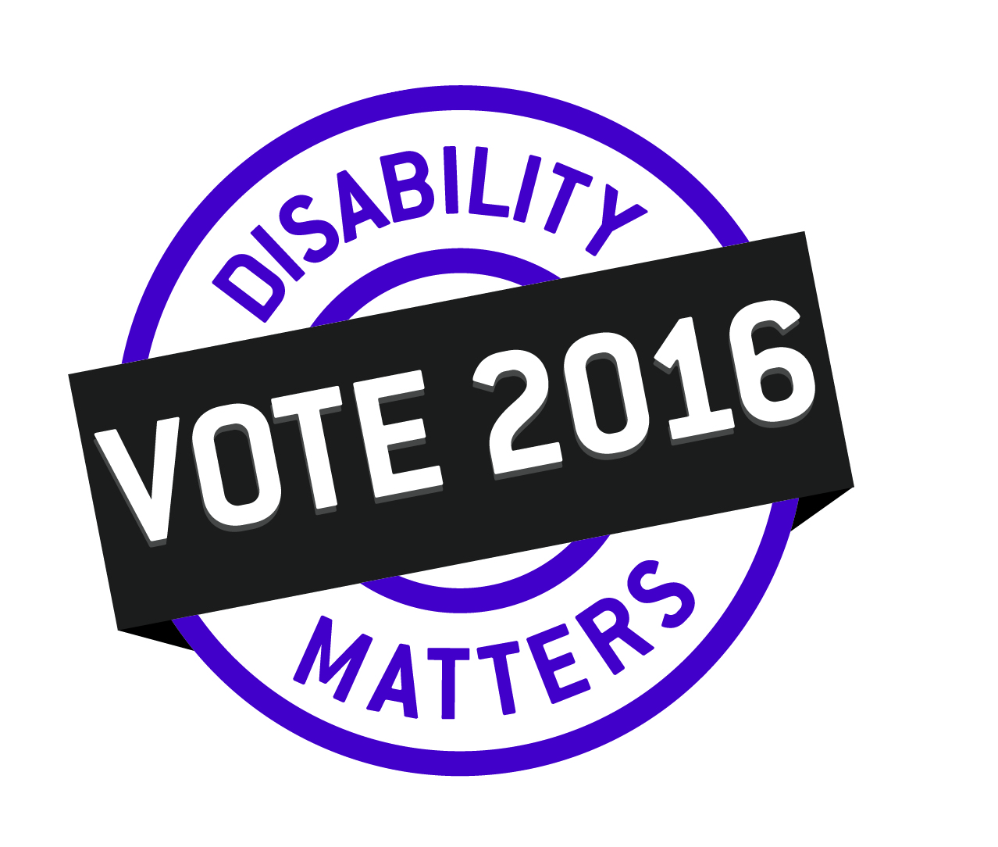

Priority Issues and
Questions for the Parties

February 16, 2016
Priority Issue: Full Accessibility
A Fully Accessible Manitoba
Manitobans with disabilities have the human right to fully participate in all aspects of public life – where people work, study, shop and recreate. This right is enshrined in provincial, national and international law. But it has never been the reality. People with disabilities have historically faced and still continue to face pervasive barriers that limit their full citizenship in Manitoba.
The landmark Accessibility for Manitobans Act (AMA) was enacted to close the wide gap that exists between human and legal rights and the everyday experience of 175,000 Manitobans with disabilities. The historic Act passed Third Reading with all party, unanimous member support in the Legislative Assembly on December 3, 2013.
The AMA promised a decade of action with significant progress toward full accessibility to be achieved by 2023.
Two years have now passed and progress has been slow. Only one of five promised accessibility standards has been developed. At this pace, it will take the full ten years before this first set of standards is even in place. This is just way too long to have to wait for long overdue progress on removing the barriers faced by Manitobans with disabilities. As Martin Luther King Jr. reminded us, “A right delayed is a right denied”.
It is also troubling that the government has yet to develop a plan on how it will monitor and enforce compliance with these standards. The first standard came into force on November 1, 2015 and will apply to more than 36,000 organizations in Manitoba. How will we know if they are meeting the requirements? How will we even know if these organizations are aware of what is required of them?
A final concern is the clear mismatch between the leadership roles that Manitobans with disabilities need to play in the implementation of the AMA, and the resources available to support these roles. The government’s own Accessibility Advisory Council recommended that government provide financial resources to disability communities to support research and consultations. This is critical to ensuring that Manitobans with disabilities have the same level of access to independent technical and legal resources and advice as other stakeholder groups (e.g. business, municipalities, government departments) at the AMA ‘table’. No such resources have been provided to date.
Questions for the Parties:
- Is your party committed to the full and timely implementation of the Accessibility for Manitobans Act (AMA) that was passed with all party support in December 2013?
- Will your party commit to establishing standards in the following areas during the next term in office: employment, transportation, information and communication, and built environment?
- What will your party do to ensure that organizations follow the standards that are developed?

Priority Issue: Fair Wages
Fair Wages for those Serving Manitobans with Intellectual Disabilities
The safety and well-being of thousands of Manitobans with intellectual disabilities depends on the consistency and quality of care and support provided by community-based agencies across Manitoba. Providing such care and support is very difficult for these agencies that report turnover rates for front line staff that range from 25% to over 66%.
As for all Manitobans, much of the richness of life for persons with intellectual disabilities comes from developing and sustaining close relationships with those who live with us and who care for us. This is a tremendous challenge given these turnover rates. It is estimated, for example, that even at a 40% turnover rate an adult with an intellectual disability participating in both residential and day services will receive care from as many as 164 different staff over a 10-year period. From age 18 to age 65, that translates into more than 770 different staff.
The primary reason for these high rates of staff turnover is that disability support workers are among the lowest paid human service workforces in Manitoba. Their work is seriously undervalued and they are paid significantly less than others working in caring professions like child-care and homecare. The low wages not only translate into high turnover, low wages also translate into staff shortages, difficulty recruiting staff with relevant knowledge and skills and ultimately, reduced quality of care.
After many years of inaction, the government has just begun to address part of this issue. As of January 1, 2016, the starting hourly wage for a disability support worker in residential services will be $13.75 but with little room for further increases. The average hourly wage of disability support workers in day services is as low as $12.06. Many who have made long-term commitments to this work are still getting only $12.06 per hour after 20 years. These are not fair living wages and they don’t provide viable career options for most people.
Manitobans with intellectual disabilities deserve well-trained, qualified staff who are paid a fair living wage. This will significantly improve the quality of life of thousands of Manitobans with intellectual disabilities.

Questions for the Parties:
- What will your party do to ensure a stable, fairly paid and qualified work force providing service to Manitobans with intellectual disabilities?
- Will your party commit to eliminating the wage disparities currently in place for Disability Support Workers?
- Will your party commit to implementing standards and equitable wages for all Disability Support Workers comparable to other caring professions in Manitoba?

Priority Issue: Timely Access
Timely Access to Services for Manitobans with Disabilities and their Families
Manitobans with disabilities look to government to develop, manage and fund services that provide essential supports and enable them to participate in all aspects of the community. Some Manitobans with disabilities receive prompt and effective services. But many other Manitobans with disabilities and their families have very real, pressing and often urgent needs that simply are not being met.
The failure of these systems comes at a very high cost. At the most fundamental level, the human costs are enormous. Long delays in accessing different programs mean months and even years of anxiety and crisis. Due to wait lists, some individuals no longer meet the eligibility requirements by the time their turn arrives, resulting in significant loss of opportunities and unrealized potential.
These failures create long-term costs to the public purse and taxpayers. Delayed care leads to more acute issues and an increased use of much more costly medical and non-medical government services, including the criminal justice system and health care system. For many types of disabilities, the important choice is to pay a little now to provide effective services when they are first needed, or to pay a lot more later because the needs were not met when effective programming could have made a lasting difference. And the current and future well-being of Manitobans with disabilities and their families lie in the balance.
- Waiting lists for early intervention services for children with autism now exceed two years. Most disturbing is that some of these children never actually receive these essential supports because they are too old and are no longer eligible when the services become available.
- People with Post Traumatic Stress Disorder (PTSD) and other mental health issues currently do not have timely access to treatment. Waiting lists for access to psychologists in the public health system is an estimated two years.
- Some families with adult children with intellectual disabilities are waiting up to ten years, and sometimes even longer, to access residential services.
- The wait times for homecare services required by persons with disabilities and seniors living in the community in Winnipeg and southern Manitoba is 37 and 31 days respectively after first referral. Even then, Manitoba’s Auditor General found that the services provided were not always reliable.
Compounding these delays, the processes for accessing many of the services are not clear, reliable information on waiting lists are not publicly available, and no one seems accountable for system performance.
Timely access to disability services is good public policy. It’s also Manitoba’s obligation under the Article 26 of the United Nations Convention on the Rights of Persons with Disabilities (CRPD).
Questions for the Parties:
- What will your party do to ensure the comprehensive reduction of wait times for disability services?
- Will your party commit to a transparent and accountable system of measuring and publicly reporting on progress towards reductions in wait times for disability services?

Priority Issue: Unleashing Employment Potential
Unleashing the Employment Potential of Persons with Disabilities
Persons with disabilities represent a largely overlooked workforce in Manitoba. Of the 87,120 Manitobans with disabilities between the ages of 15 and 64, a full 35,000 are either unemployed or are not actively seeking paid employment. Thousand more are underemployed. That is an incredible waste of human and economic potential.
Research shows that persons with disabilities are work-competent, reliable, and hard-working individuals. Research also demonstrates that accommodations provided to employees with disabilities typically cost little or nothing while contributing to higher staff retention, increased productivity and improved organizational culture and climate.
The accessible employment standard under The Accessibility for Manitobans Act, if effective will help remove many of the employment barriers faced by persons with disabilities. However, nationally and internationally we’ve seen that these standards alone aren’t enough. That’s because:
- The design and delivery of some government programs actually discourage persons with disabilities from seeking employment.
- Current government systems and services struggle to support a successful transition from high school to work life.
- Lack of accommodations, stigma and systemic low levels of expectations for persons with disabilities continue to limit opportunities and access to resources in our schools, colleges and universities.
- Many employers continue to hold misconceptions and misunderstandings about the capabilities and potential of persons with disabilities.
- Inclusive, community based employment services for Manitobans with intellectual disabilities remain at the margins of the current continuum of service options.
With a significant labour shortage forecast in Manitoba in the decades ahead, government needs to provide stronger leadership to realize the employment potential of persons with disabilities.
Questions for the Parties
- What will your party do to ensure equity in employment for Manitobans with disabilities within the Government of Manitoba?
- What will your party do realize the employment potential of persons with disabilities within the broader provincial economy?
- What will your party do to ensure that Manitobans with disabilities are promoted to the business community as valuable and viable contributors to the workforce?

Priority Issue: Dignified Income
Dignified Incomes for Persons with Disabilities Facing the Most Profound Barriers to Workforce Participation
Achieving economic independence through full-time employment is the best option for most Manitobans with disabilities. But this simply is not possible for many who have severe and prolonged or permanent disabilities. These persons face the most profound barriers to labour market success and many must rely on the government’s Employment and Income Assistance (EIA) program to meet their most basic needs.
As a result, many persons with severe and prolonged disabilities are condemned to live on incomes well below the poverty lines, some from age 18 through to age 65 when they become eligible for Old Age Security (OAS) and Guaranteed Income Supplement (GIS).
The EIA program was never designed to meet the needs of persons with severe and prolonged disabilities over a long period of time. Rather EIA was designed to be a program of last resort that provides short-term assistance during transitional periods of unemployment. To encourage the transition to employment, EIA’s basic needs benefits are kept below prevailing wages levels and generally accepted measures of poverty. Being reliant on EIA carries considerable stigma and reporting requirements are made deliberately onerous to discourage dependency and protect public funds.
There have been calls, both nationally and provincially, for the development of alternative income support programs for persons with severe and prolonged disabilities to provide a socially acceptable standard of living. These calls for reform are based in the reality that these persons with disabilities are the most likely to be living in poverty while also facing the most pervasive barriers that prevent their full participation in the community.
Alternative income programs already operating in Saskatchewan (SAID) and Alberta (AISH) are making a significant difference in the quality of life and inclusion for persons with severe and prolonged disabilities. These programs also provide the basis for developing a type of program that will work best in Manitoba.

Questions for the Parties:
- What income level does your party see as being socially acceptable for Manitobans with severe and prolonged disabilities who face profound barriers to labour market success?
- Will your party commit to introducing an alternative income program for Manitobans with severe and prolonged disabilities during the next term in office?

