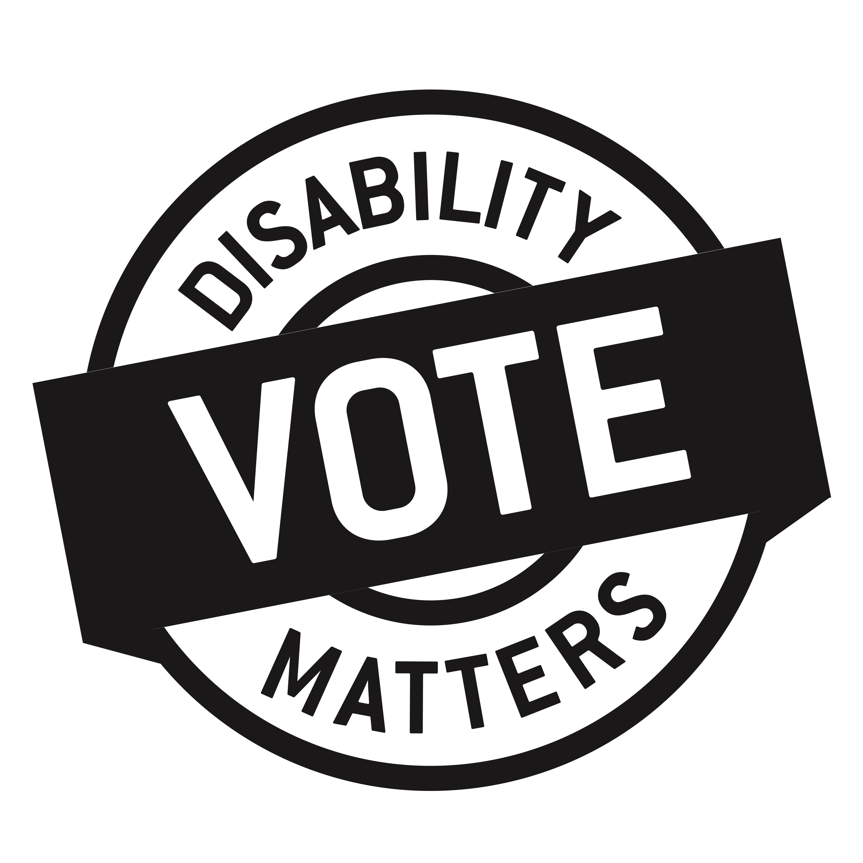  Campaign Goals  - To ensure all Manitobans with disabilities can participate fully in election activities and those eligible to vote are able to do so.  - To promote priority attention for disability issues in the election.  - To support Manitobans with disabilities in making informed voting decisions.  www.dmvote.ca  info@dmvote.ca  @DMVoteMB DisabilityMattersVoteMB |  | Campaign Goals  - To ensure all Manitobans with disabilities  can participate fully in election activities  and those eligible to vote are able to do so.  - To promote priority attention for disability issues in the election.  - To support Manitobans with disabilities in making informed voting decisions.  www.dmvote.ca  info@dmvote.ca  @DMVoteMB DisabilityMattersVoteMB  Campaign Goals  - To ensure all Manitobans with disabilities  can participate fully in election activities  and those eligible to vote are able to do so.  - To promote priority attention for  disability issues in the election.  - To support Manitobans with disabilities  in making informed voting decisions.
Campaign Goals  - To ensure all Manitobans with disabilities  can participate fully in election activities  and those eligible to vote are able to do so.  - To promote priority attention for disability issues in the election.  - To support Manitobans with disabilities in making informed voting decisions.  www.dmvote.ca  info@dmvote.ca  @DMVoteMB DisabilityMattersVoteMB |  | www.dmvote.ca  info@dmvote.ca  @DMVoteMB DisabilityMattersVoteMB

