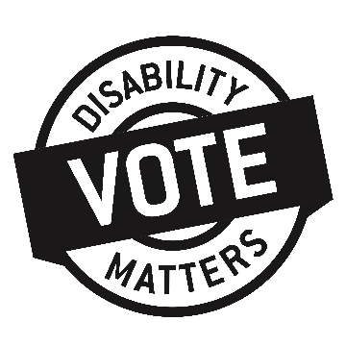
Name of candidate
Address
City, Province, Postal Code
DATE

Dear <CANDIDATE NAME>:
I live in your riding and am a volunteer with the Disability Matters Vote campaign.
DMVote is a non-partisan, cross-disability campaign to raise awareness around disability issues in Manitoba. We are supporting people with disabilities to have access to all of the information they need to make an informed vote on September 10th, and ensuring the polls are accessible.
DMVote is focusing on five priority issues:
- Timely access to disability-related services
- Fair living wages for direct support professionals
- A fully-accessible Manitoba
- Unleashing the employment potential of people with disabilites
- Dignified incomes for people facing profound and permanent barriers to workforce participation
We would like to meet with you to discuss these issues and your commitment to addressing them, if you are elected. I have attached fact sheets on each of the above issues for your information.
Please let me know when we can meet. I can be reached at: INSERT PHONE and INSERT EMAIL ADDRESS. I look forward to meeting with you.
Sincerely,

