PROVINCIAL ELECTION, APRIL 19, 2016:
HOMEBOUND VOTING INFORMATION
What is homebound voting?
Homebound voting is a voting opportunity that allows voters and their caregivers to vote at home.
Who can use homebound voting?
- A voter who is unable to go in person to a voting station due to a disability
- A voter who is providing care to a person who is unable to leave home
Caregivers must actually be living with the homebound voter and not able to go to a voting station during advance voting (April 9 to 16) or on Election Day to vote.

How do I apply?
Option 1: Enumerators carry homebound voting applications when they visit your home to add your name to the voters list.
The enumerator can complete the application for you at the door. He or she will read aloud the declaration on the application and you will be asked to sign it.
ID is not required as part of the application.
Option 2: You can apply by contacting your returning office. Your returning office phone number can be found on the Elections Manitoba website: www.electionsmanitoba.ca, or you can call 204-945-3225, toll-free: 1-866-628-6837.
How do I vote?
The returning officer will make an appointment with you to administer the vote in your home. The appointment will take place after March 29.
Two voting officials will visit you to administer the vote. They will bring a homebound voting kit with instructions. They will explain the process to you and may assist you to vote, if required.
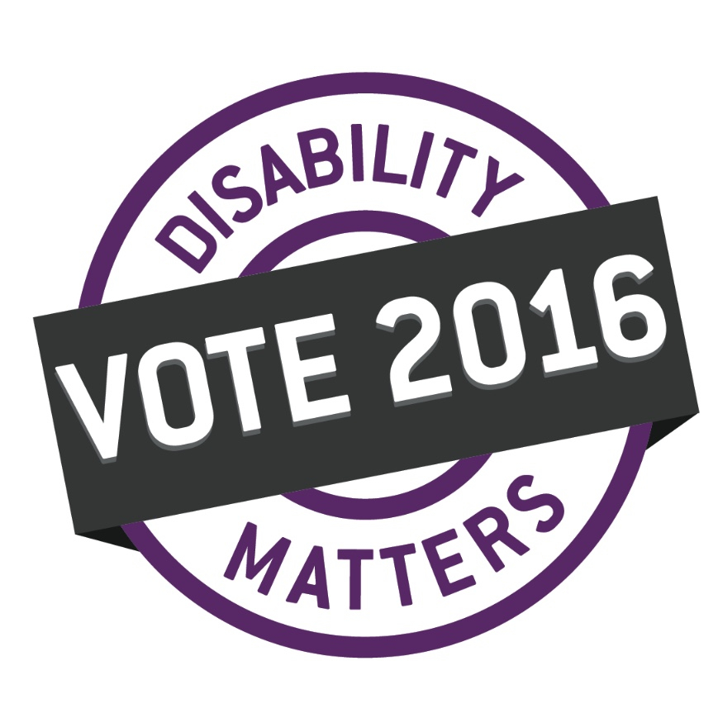
You vote using a regular ballot. The voting officials will take your completed ballot kit to the returning office where they will place your ballot in a ballot box.
Provided by vote@disabilitymatters.ca

