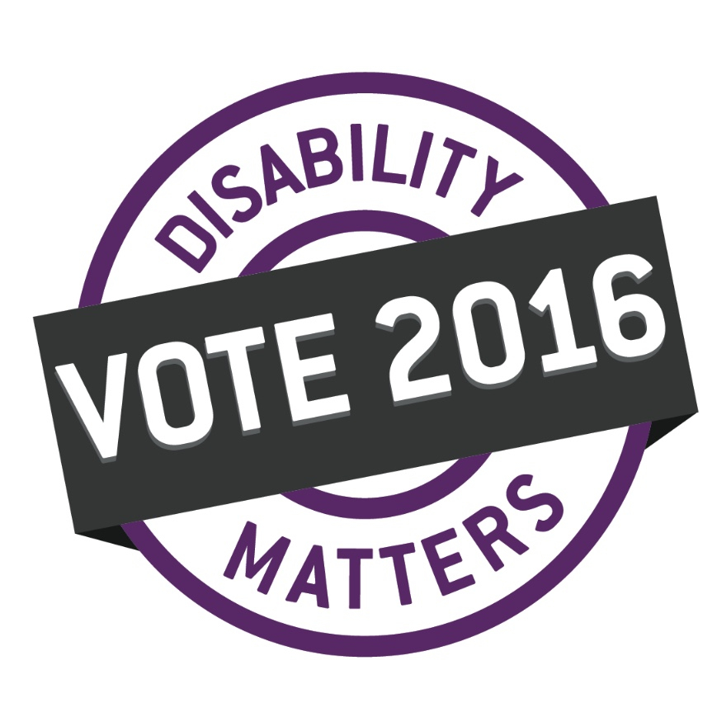
vote@disabilitymatters.ca
www.disabilitymatters2016.ca
Disability Matters: Vote 2016
RPO Box 26131 676 Portage Avenue
Winnipeg, MB R3G 0M4
facebook.com/DisabilityMattersMB twitter.com/DMV2016MB

The Provincial Election is April 19, 2016

The people you support have a right to vote,
and it’s your job to ensure they can.
Enumeration is the first step.

WHO CAN VOTE?
Anyone who is over the age of 18, is a Canadian citizen and has lived in Manitoba for at least 6 months immediately before Election Day has the right to vote.
Enumeration is the process of going door to door to create a full list of voters to prepare for an election. Elections Manitoba will send enumerators to collect names, gender, birthdates and addresses of adults living in each home. They are identifiable by their yellow vests and signed and dated ID tag.
WHAT’S ENUMERATION?

What do you do when an enumerator comes to the house
you work at?
WHAT?

• If the person you support is able and willing to add their name to the voters list, they can speak to the enumerator themself.

• If the person you support is unable to give his/her own information, with consent, you can give the enumerator the name(s) of the people who live at the house, apartment, etc.

Enumeration will happen from February 4, 2016 – March 7, 2016.
WHEN?

WHY?
To be able to make a choice about whether to vote, the people you support need to be on the voters list. Enumeration is the process of going door to door to collect names for the voters list.

If nobody is home when the enumerator comes, they will leave a “Sorry we missed you” door hanger.

ALSO

Each person you support can still be added to the voting list by registering at their returning office. This needs to be done between March 10 and April 7.

A list of returning offices will be on the Elections Manitoba website
www.electionsmanitoba.ca under “My Voting Information” by February 4.

If the person you support is physically unable to attend their voting location, ask the enumerator for an application for “Homebound Voting”.

More information about the voting process will be shared in the coming weeks. To help someone prepare for an enumerator to visit please explain this process in advance and encourage them to check out the Elections Manitoba and Disability Matters website www.disabilitymatters2016.ca.

It’s your responsibility to ensure that each person you support has the option and the opportunity to vote in the election. It’s a human right.

